User guide of the user interface :

When you launch the function «GUI_interactive_graph.m», this window opens :

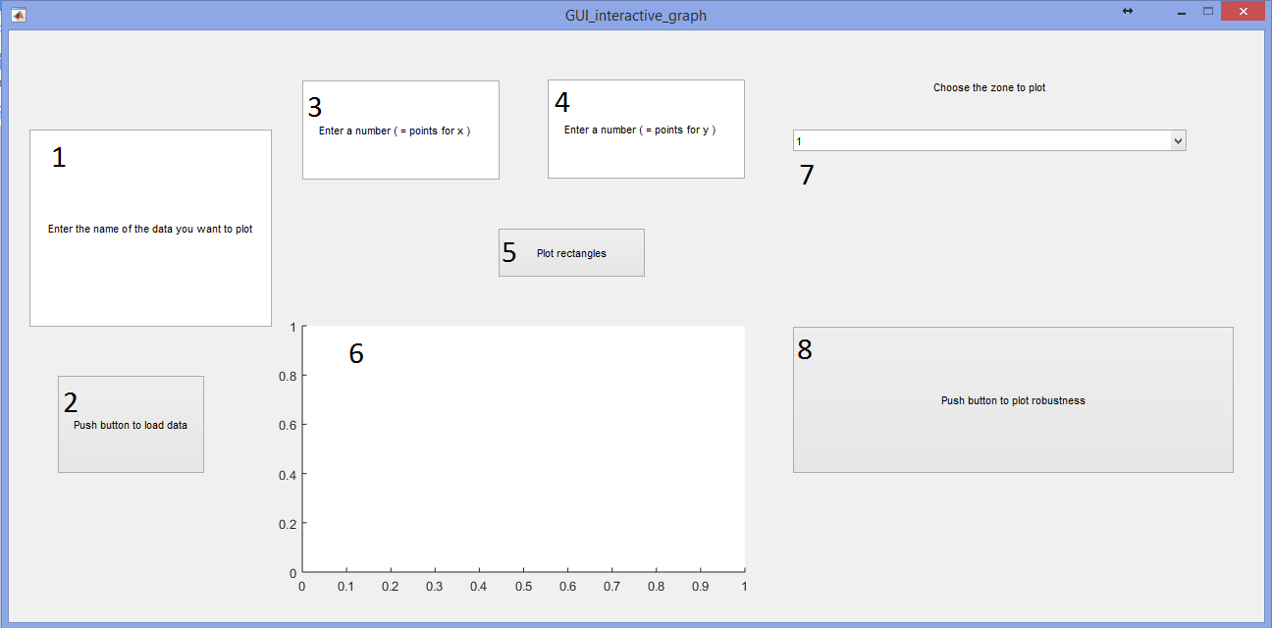

The first thing to do is to enter the name of the file contening your data. For instance in my case I have a file named ‘Experience1.mat’ contening the data so I enter Experience1 in frame 1 and **press ok** (pressing ok is really important, if you don’t do so the changes won’t be taken into account) :

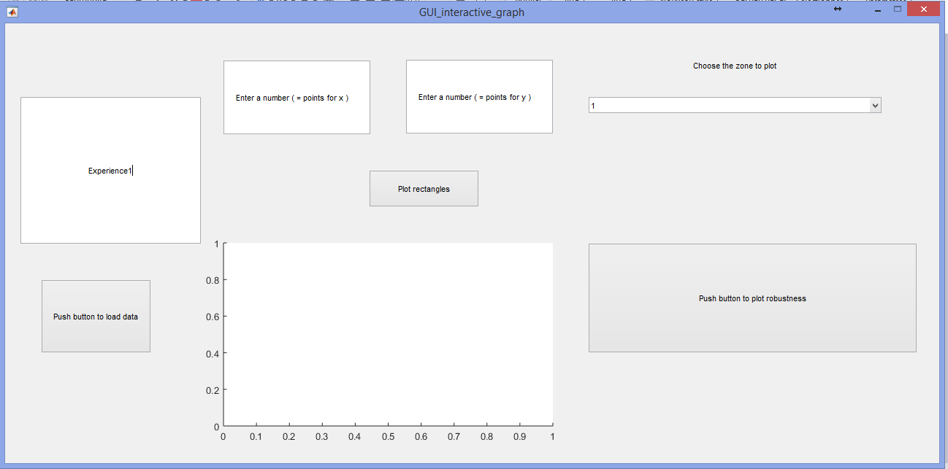

Press button 2 (‘Press button to load data’) to save you data into your workspace. If it’s done you should see on the fdshbgdh : ‘Data loaded’ like this :

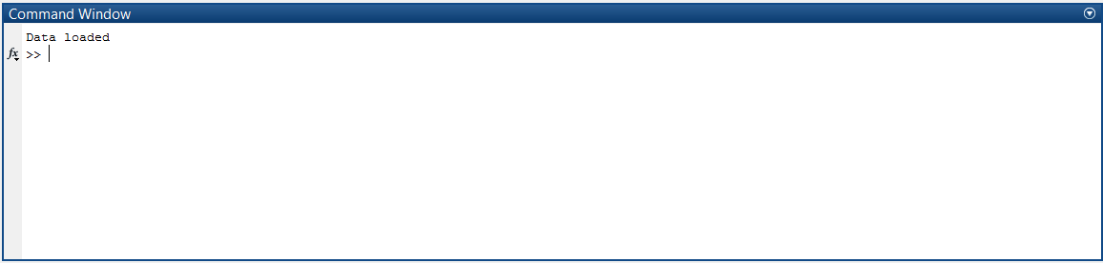

You have then to fill frame 3 and 4 by selecting the projection dimension you want to plot. For instance if I want to plot projection dimension 1 and 2 I enter ‘1’ in frame 3 (‘Enter a number ( = points for x )’) and **press ok** and ‘2’ in frame 4(‘Enter a number ( = points for y)’) and **press ok** like this :

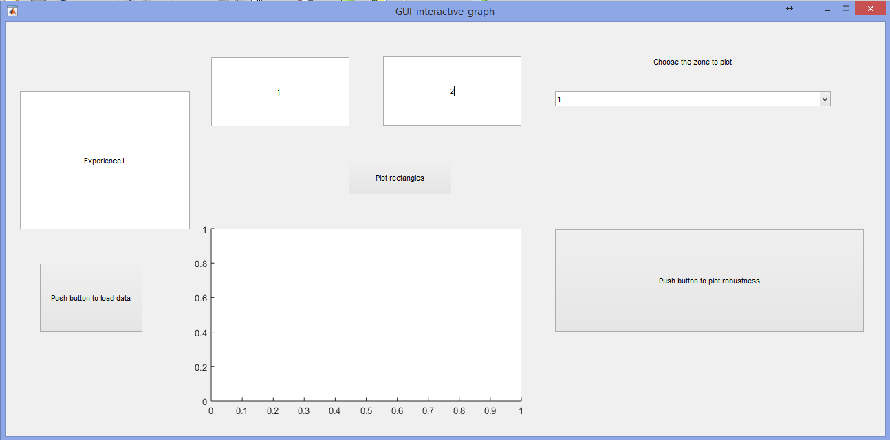

Then you press button 5 (‘plot rectangles’) and the following graph should appear in section 6 :

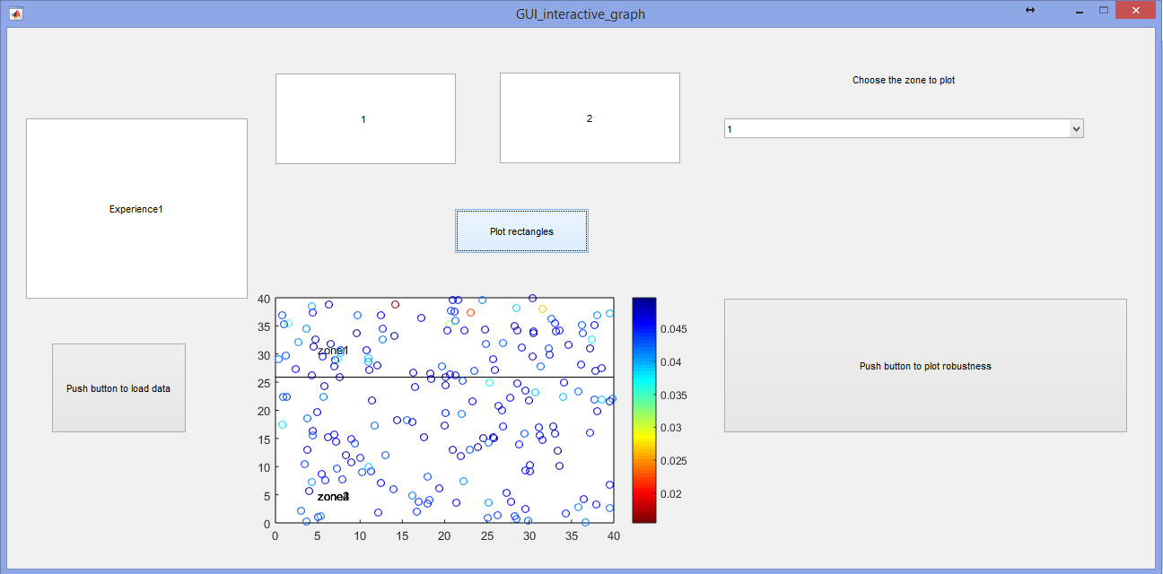

You can see that two rectangles are plot. Each point is colored according to the value of its robustness. The point with the lowess robustness is in zone1 so if you want to plot only zone one you can select ‘1’ in the pop-up menu in zone 7 and you push button 8 (‘Push button to plot robustness’) and a new figure will appear, like this :

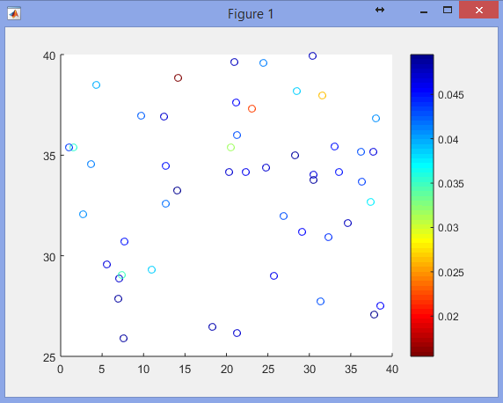

Once again each point is colored according to the value of its robustness. If you want to see this precise value you can click on the point and its value will be written next to the point. The point with the lowest robustness is the point coloured in dark red. Let’s click on it :

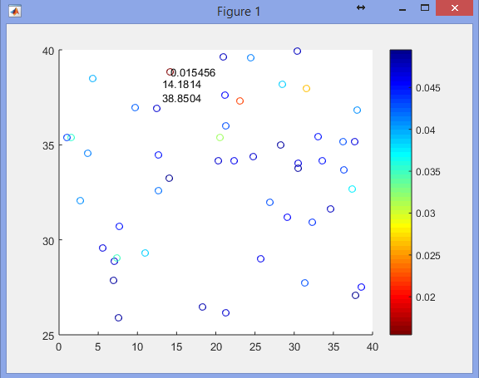

Its robustness value is 0.015456.

The position of the point is also written on the figure. Here the x value of the point is 14.1814 and its y value is 38.8504.

This value is also displayed :

